Ammar Ahmed BDS2B2
20L-0961

Lab 9 Tasks
Question 1:
(a)
A₁ | A₀ | B₁ | B₀ | A<B | A=B | A>B
0 | 0 | 0 | 0 | 0 | 1 | 0
0 | 0 | 0 | 1 | 1 | 0 | 0
0 | 0 | 1 | 0 | 1 | 0 | 0
0 | 0 | 1 | 1 | 1 | 0 | 0
0 | 1 | 0 | 0 | 0 | 0 | 1
0 | 1 | 0 | 1 | 0 | 1 | 0
0 | 1 | 1 | 0 | 1 | 0 | 0
0 | 1 | 1 | 1 | 1 | 0 | 0
1 | 0 | 0 | 0 | 0 | 0 | 1
1 | 0 | 0 | 1 | 0 | 0 | 1
1 | 0 | 1 | 0 | 0 | 1 | 0
1 | 0 | 1 | 1 | 1 | 0 | 0
1 | 1 | 0 | 0 | 0 | 0 | 1
1 | 1 | 0 | 1 | 0 | 0 | 1
1 | 1 | 1 | 0 | 0 | 0 | 1
1 | 1 | 1 | 1 | 0 | 1 | 0
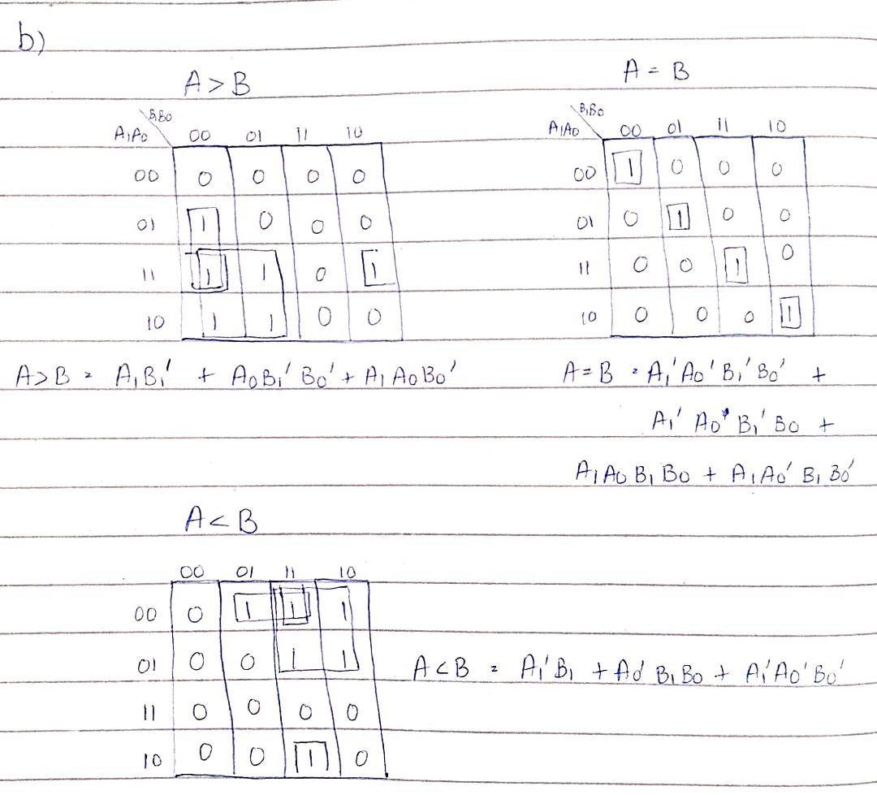
(c)
IC Type | Required No. of Gates | Gates per IC | Required No. of ICs
74LS08 | 7 | 4 | 2
74LS32 | 2 | 4 | 1
74LS04 | 4 | 6 | 1
74LS86 | 2 | 4 | 1
Total no. of ICs | 5

Qusetion 2:
4-bit full Adder:
Adder when K=0
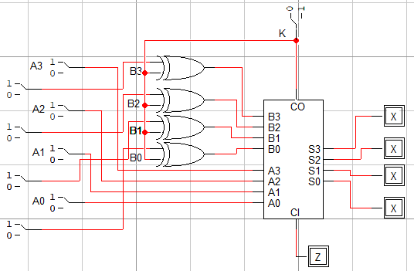
4-bit full Subtractor:
Subtractor when K=1
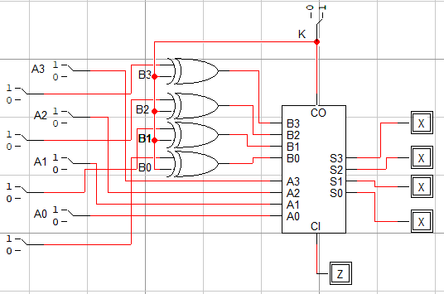

Question 3:
4-bit full Multiplier:
